🥇 LlamaIndex
Facilita lo sviluppo di applicazioni basate su LLM (Large Language Model) e integra facilmente varie fonti di dati con i LLM.
🥈 vLLM
Progettato per migliorare le prestazioni durante l'inferenza, ottimizza e accelera l'uso dei LLM.
🥉 llama.cpp
Uno degli inference engine più diffusi per modelli come LLaMA, Qwen, Mistral e molti altri. Da non confondere con i modelli LLaMA di Meta!
🏅 Open-webui
Open source e intuitivo, semplifica la creazione di interfacce per app AI.
🏅 ComfyUI
Interfaccia web per Stable Diffusion, modello che serve a creare immagini AI Generated.

🥇 Claude di Anthropic:
Strumento conversazionale multiuso che usiamo principalmente per generare idee e ottenere nuovi spunti.

🥈 Perplexity AI
Uno strumento molto utile se devi trovare dati e informazioni rapidamente!

🥉 Midjourney
Lo strumento perfetto se devi creare delle immagini accattivanti!

🏅 Aider
Un assistente che suggerisce codice ed è anche in grado di spiegarlo.

🏅 GitHub Copilot
Uno strumento molto utile per risparmiare tempo nella scrittura del codice, soprattutto per righe di codice ripetitive.

🥇 QwQ-32B-Preview
Un modello sviluppato per risolvere problemi complessi come quelli legati al coding e alla matematica.

🥈 Flux Schnell
È un modello da 12 miliardi di parametri in grado di generare immagini da testo.

🥉 Deepseek coder v2
Uno dei migliori modelli sviluppati per il coding, con prestazioni paragonabili a GPT4-Turbo in task specifiche di programmazione.

🏅 LLaMA 3.2
L’ultima versione del modello multimodale di Meta, ha ottime prestazioni e diversi tipi di applicazioni!

🏅 Moshi
Uno dei primi modelli voice-to-voice, è in grado di ricevere la voce in input e generare in output sia del testo che una risposta vocale.

AI Coding Assistant
Build an LLM-powered coding assistant that can act as a real-time pair programmer. This tool should provide suggestions, write code snippets, debug existing code, and even offer real-time explanations on complex logic during a live coding session.
When building such an app, ensure:
- Good choice of LLMs that are good at code generation
- IDE integration, such as VS Code extension, for in-editor functionality.
- Contextual awareness from the current coding environment—libraries used, files open, and the like
Check out ADVANCED Python AI Agent Tutorial – Using RAG for a complete walkthrough of building a coding assistant.

LLM-Powered Code Migration Tool
There are off-the-shelf solutions, but you can also try building code migration tools from scratch. Build a tool that can analyze code written in one programming language and convert it into another language, using LLMs to understand the original logic and reimplement it in the target language. For example, you may want to migrate Python code to Go or Rust.
You have to experiment with the following:
- Choice of LLMs for code translation between languages
- Static analysis tools to ensure logical correctness after translation
- Support for different paradigms and language-specific constructs
Such an app can help migrate legacy codebases to newer, more performant languages with minimal manual rewriting.
Create AI Chatbots and Virtual Assistants
Another way to make money with AI is by creating and selling AI chatbots. Customer service is a key part of any business, especially on WordPress, as it ensures customer satisfaction.
You can build chatbots that offer 24/7 support, answer frequently asked questions instantly, or even recommend products based on customer preferences. These custom chatbots can be tailored for each business that contacts you, allowing you to earn money from your expertise.
Several of our partner brands use AI chatbots for customer support and have reported positive experiences, including increased customer satisfaction.
For example, you could develop a virtual assistant for a travel site that handles bookings and provides a seamless customer experience.
To learn more, see our tutorial on how to add a chatbot in WordPress.
Expert Tip: If you plan to use this idea, then we recommend ChatBot.com for creating AI virtual assistants since it is the best AI chatbot software.
Provide AI Translation Services
Many business owners are looking to create multilingual websites to reach a global audience and increase conversions. AI-powered translation tools offer an efficient way to do this.
You can use AI to provide translation services, helping businesses communicate with different markets. AI tools are faster than traditional plugins and keep the tone and style consistent across the site. They also handle large volumes of content quickly and accurately.
Keep in mind that AI can sometimes miss details and make mistakes. That is why it is a good idea to also have human translators as proofreaders to ensure everything is correct.
Bonus: SeedProd is a top-notch page builder that can also be used as an AI-powered translation tool. It can translate your custom page’s content into over 50 languages, making it a great choice.
If you are looking for a free solution, then you can opt for Translate WordPress. It is a popular plugin that uses Google AI to translate your website.

https://blog.gopenai.com/introduction-to-llm-agents-how-to-build-a-simple-reasoning-and-acting-agent-from-scratch-part-1-843e14686be7
https://blog.gopenai.com/building-llm-agents-from-scratch-part-2-a-conversational-search-agent-with-ollama-a4544b2291cf

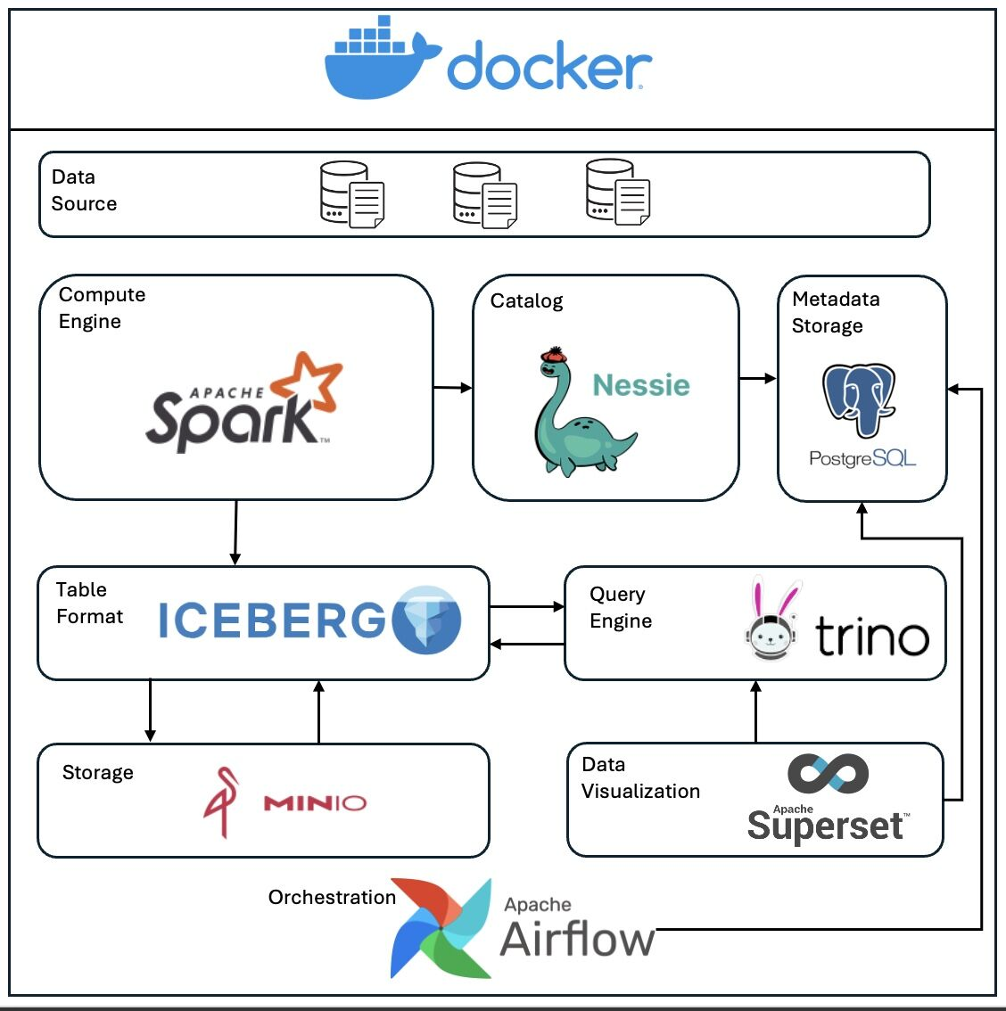🚀 Learn Data Engineering: Inspired by Zach Wilson Architecture
Here’s a Docker Compose setup to practice data engineering hands-on. Build, query, and visualize pipelines in one environment.
🛠️ What’s Included?
1️⃣ Apache Spark: Distributed data processing for ETL pipelines.
2️⃣ Apache Iceberg: Manage schema evolution and time travel in data lakes.
3️⃣ Project Nessie: Version-control datasets like Git.
4️⃣ Apache Airflow: Orchestrate workflows and automate pipelines.
5️⃣ Trino: Query multiple data sources with federated SQL.
6️⃣ Apache Superset: Build stunning dashboards.
7️⃣ MinIO: S3-compatible object storage for your data lake.
8️⃣ PostgreSQL: Store metadata and structured data.
⚡ Quick Start
1️⃣ Clone the repo:
git clone https://lnkd.in/gcsJt_Ej
cd data-engineering-stack
2️⃣ Start the stack:
docker-compose up -d --build
Apache Iceberg, Apache Spark, Trino Software Foundation, PostgreSQL Global Development Group, MinIO
Edit: Using this architecture for a NYC Taxi Data Project: https://lnkd.in/gWMj6RS7. You'll be seeing the bucket name as nyc-project

